TWO DIGIT SUBTRACTION
KS1 – 2001 Paper
1.
24

KS1 – 2002 Paper
2.
KS1 – 2003 Paper 1
3.
KS1 – 2004 Paper 2
4.
KS1 – 2005 Paper 1
5.
13

KS1 – 2005 Paper 2
6.
43

KS1 – 2007 Paper 1
7.
KS1 – 2009 Paper 1
8.
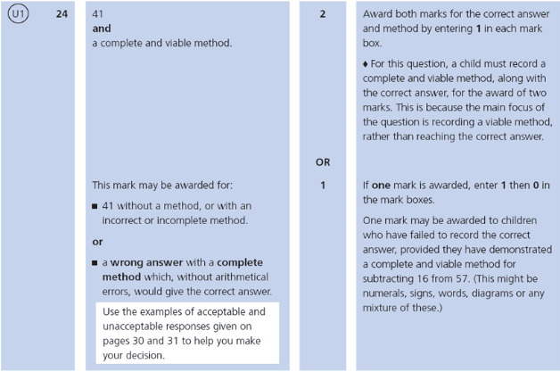
KS1 – 2016 Paper - Arithmetic
9.
10.
11.
12.
13.
14.
15.
KS1 – 2016 Paper - Arithmetic (Second)
16.
17.
18.
19.
KS1 – 2017 Paper – Arithmetic
20.
21.
22.
KS1 – 2017 Paper – Arithmetic
23.
24.
KS1 – 2018 Paper – Arithmetic
25.
26.
27.
28.
29.
30.
31.
32.
KS1 – 2019 Paper – Arithmetic
33.
34.
35.
36.
37.
38.
39.
40.
41.
KS1 – 2022 Paper – Arithmetic
42.
43.
44.
45.
46.
47.
48.
49.

